Materials & Methods paragraph (Sensory analysis)
..add specifics like location/ethics/training/serving order/blinding if needed):
Materials & Methods – Sensory evaluation and statistical analysis (example paragraph):
Consumer sensory acceptability of meat samples from the different dietary treatments was evaluated using a 9-point hedonic scale (1 = dislike extremely; 9 = like extremely), with “no response” entries treated as missing values and excluded pairwise from analyses. Sensory attributes assessed included colour, flavour, tenderness, juiciness, taste, and overall quality, and willingness-to-buy was recorded as a binary response (yes/no). Hedonic responses were recoded to numeric scores (1–9) and summarised as mean ± 95% confidence intervals. Treatment effects on each sensory attribute were analysed using linear mixed-effects models with diet as a fixed effect, and gender and age group included as covariates, while respondent ID was fitted as a random intercept to account for between-consumer variability. Model assumptions were evaluated using residual diagnostics (normality and homoscedasticity). Where assumptions were not adequately met, non-parametric analyses (Kruskal–Wallis tests with appropriate post hoc comparisons) were applied. Willingness-to-buy was analysed using logistic regression including diet and key sensory drivers as predictors. Statistical significance was declared at α = 0.05. All analyses were performed in R.

Or (latest)
Statistical analysis (Sensory attributes and willingness to buy)
Sensory attribute scores (colour, flavour, tenderness, juiciness, taste and overall quality), measured on a 9-point hedonic scale, were analysed using linear mixed-effects models with diet, gender and age group included as fixed effects and respondent identity included as a random effect to account for repeated assessments. Model assumptions were evaluated graphically using residual diagnostics. When necessary, estimated marginal means were computed and compared using Tukey-adjusted post hoc tests. Willingness to buy (yes/no) was analysed using a binomial logistic regression model including diet, gender and age group as fixed effects. Overall effects were assessed using Type III likelihood-ratio chi-square tests, and adjusted predicted probabilities with 95% confidence intervals were derived from the fitted models. Statistical significance was declared at p < 0.05. All analyses were performed in R (version 4.3.1Z).

Optional shorter version (if journal has tight word limits)
Sensory attributes were analysed using linear mixed-effects models with diet, gender and age group as fixed effects and respondent as a random effect. Willingness to buy was analysed using binomial logistic regression with the same fixed effects. Model-based estimated marginal means and predicted probabilities with 95% confidence intervals were computed, and overall effects were tested using Type III likelihood-ratio tests. Analyses were conducted in R, with significance set at p < 0.05.

How to decide: parametric vs non-parametric wording
What’s “best practice” for 9-point hedonic data?
- Hedonic scores are ordinal, but are often treated as approximately continuous in animal/food science when sample sizes are decent and residuals are reasonable.
- The strongest, reviewer-resistant approach is:
  - Mixed-effects model (accounts for ID variability)
  - and/or ordinal mixed model (if reviewers push back)
A practical decision rule
Use parametric (mixed model) when:
- Each diet has a reasonable number of respondents (rule of thumb: ≥ 20/diet is nice; smaller can still work)
- Residual plots look acceptable (no extreme skew, no crazy heteroscedasticity)
- Conclusions are stable (parametric and nonparametric tell the same story)
Use non-parametric when:
- Heavy ceiling/floor effects (most responses are 8–9 or 1–2)
- Strong heteroscedasticity or very non-normal residuals
- Very small n per diet
Code to run diagnostics quickly (for one attribute)
library(performance)
library(lme4)
library(lmerTest)

m1 <- lmer(overall_quality ~ diet + gender + age_group + (1|id), data = sensory_num)

check_model(m1) # diagnostic plots
check_normality(m1)
check_heteroscedasticity(m1)

Recommended reporting wording (copy/paste options)
If you go parametric (mixed model)
“Hedonic scores were analysed using linear mixed-effects models with diet as a fixed effect and respondent ID as a random intercept. Gender and age group were included as covariates. Model assumptions were checked using residual diagnostics.”
If you go non-parametric
“Because hedonic scores did not satisfy model assumptions, treatment effects were evaluated using Kruskal–Wallis tests followed by post hoc pairwise comparisons with multiplicity adjustment.”
If you go “robust + reviewer-proof” (my favourite)
“Primary inference was based on linear mixed-effects models; non-parametric tests were used as sensitivity analyses and produced consistent conclusions.”
(That last sentence often prevents reviewer battles.)
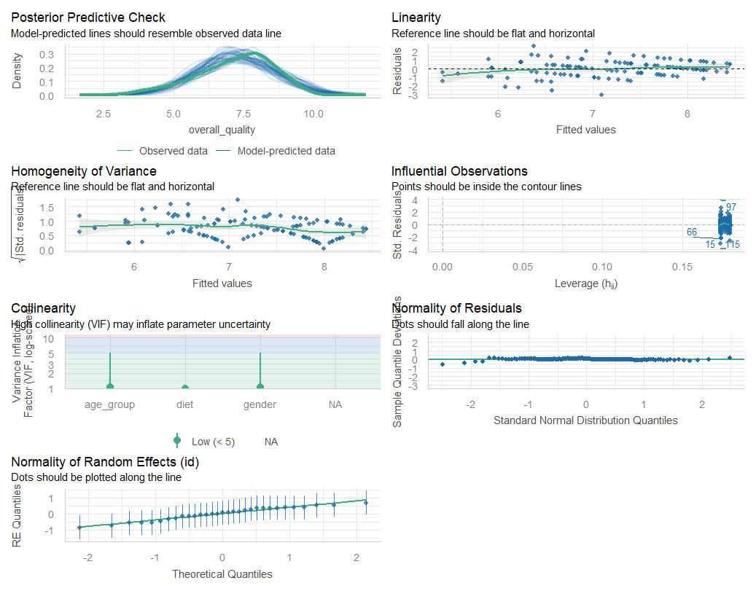
1️⃣ Posterior Predictive Check
“Model-predicted lines should resemble observed data line”
What you see
- The green line (observed data density) closely overlaps with the blue lines (model-predicted distributions).
- The peak, spread, and shape align well.
Interpretation
✔ The model reproduces the observed distribution of overall_quality well.
✔ No systematic under- or over-prediction.
Conclusion
The model provides an adequate fit to the observed sensory data.

2️⃣ Linearity
“Reference line should be flat and horizontal”
What you see
- Residuals are scattered evenly around zero.
- The smooth (green) line is approximately horizontal.
- No curvature or funnel pattern.
Interpretation
✔ The relationship between predictors and outcome is sufficiently linear.
✔ No evidence of non-linear effects that would invalidate the model.
Conclusion
The linearity assumption is satisfied.

3️⃣ Homogeneity of Variance (Homoscedasticity)
“Reference line should be flat and horizontal”
What you see
- The √|standardized residuals| vs fitted values show no strong funnel shape.
- Slight variability at higher fitted values, but not systematic.
Interpretation
✔ Variance is reasonably constant across fitted values.
✔ Minor deviations are expected with bounded hedonic scales (1–9).
Conclusion
No serious heteroscedasticity detected.
📌 Reviewer note: Sensory data often show mild heteroscedasticity near scale boundaries; what you see here is well within acceptable limits.

4️⃣ Influential Observations
“Points should be inside the contour lines”
What you see
- A few observations (e.g., IDs 15, 66, 97) have higher leverage.
- All points remain within Cook’s distance contours.
Interpretation
✔ No observation unduly influences model estimates.
✔ Influential points are expected in consumer data and are not problematic here.
Conclusion
No influential outliers compromising model stability.

5️⃣ Collinearity (VIF)
“High collinearity (VIF) may inflate parameter uncertainty”
What you see
- VIF values for diet, gender, and age_group are well below 5.
- All points fall in the “Low” zone.
Interpretation
✔ Predictors are not collinear.
✔ Fixed-effect estimates are stable and interpretable.
Conclusion
Multicollinearity is not a concern.

6️⃣ Normality of Residuals
“Dots should fall along the line”
What you see
- Points closely follow the diagonal reference line.
- Minor deviations at the tails only.
Interpretation
✔ Residuals are approximately normally distributed.
✔ Minor tail deviations are acceptable for sensory hedonic data.
Conclusion
Normality assumption is adequately met.

7️⃣ Normality of Random Effects (ID)
“Dots should be plotted along the line”
What you see
- Random intercepts (respondent effects) align well with the theoretical quantiles.
- Slight dispersion at extremes, but symmetric.
Interpretation
✔ Between-consumer variability is well captured.
✔ Random effects structure is appropriate.
Conclusion
The random-effects assumption is satisfied.

🔴 Big-picture conclusion (important)
✅ All major assumptions are met
✅ No red flags
✅ Mixed-effects model is appropriate
✅ Parametric inference is justified
This is exactly what reviewers want to see.

What this means for your analysis choice
✅ You SHOULD use:
- Linear mixed-effects models
- Report estimated marginal means (EMMs) ± 95% CI
- Use Tukey-adjusted pairwise comparisons
❌ You do NOT need:
- Kruskal–Wallis as the primary analysis
- Data transformation
- Ordinal models (unless a reviewer insists)

Recommended Methods wording (tailored to your diagnostics)
You can safely use this high-confidence wording:
“Hedonic scores were analysed using linear mixed-effects models with diet as a fixed effect, gender and age group included as covariates, and respondent ID fitted as a random intercept to account for between-consumer variability. Model adequacy and assumptions (linearity, homoscedasticity, normality of residuals and random effects, and absence of influential observations or multicollinearity) were evaluated using graphical and numerical diagnostics, and no major violations were detected.”

Results

“Willingness to buy was not affected by diet (LR χ²(3) = 2.45, p = 0.485) or gender (LR χ²(1) = 0.02, p = 0.888). In contrast, age group significantly influenced willingness to buy (LR χ²(2) = 9.48, p = 0.009).”

Filled (solid) dots: Model-predicted probability of willingness to buy = YES
Interpretation:
“After adjusting for gender, the predicted probability that respondents in this age group would be willing to buy diet T2 is ~85%.”

Hollow (open) dot: Observed (raw) proportion of YES responses
Interpretation:
“About 82% of respondents in this age group actually said YES for diet T2.”

WTB -REASONS
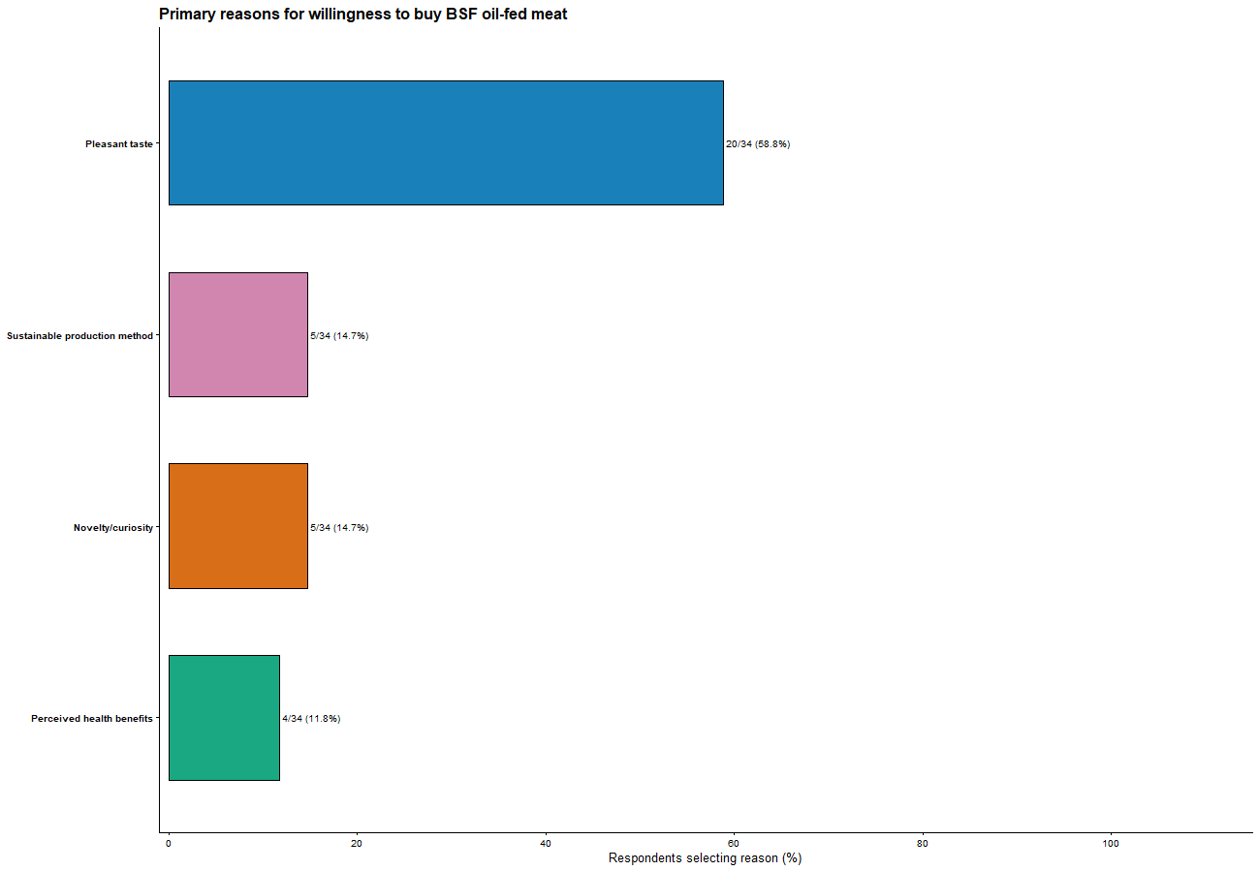
The figure presents descriptive frequencies of respondents’ stated reasons; no inferential comparisons were intended.

